A COURSE-BASED PROJECT

On

**Exploring Consumer Purchase Behavior: Insights from Retail Data Analysis**

Submitted in partial fulfillment of Data Mining & Analytics Lab

## GRIET Lab On Board (G-LOB)

By

**Anirudh Gongireddy 22241A3202**

**Fawaz Ali Siddiqui 22241A3209**

**Harsha Vardhan Reddy 23245A3221**

**Moksha Sai Reddy 22241A3230**



**Department of Data science**

### GOKARAJU RANGARAJU INSTITUTE OF ENGINEERING AND TECHNOLOGY

**(Autonomous)**

### Bachupally, Kukatpally, Hyderabad, Telangana, India,500090 2024-2025



**GOKARAJU RANGARAJU INSTITUTE OF ENGINEERING AND TECHNOLOGY**

**(Autonomous) Hyderabad-500090**

## CERTIFICATE

This is to certify that the GLOB entitled “Exploring Consumer Purchase Behavior: Insights from Retail Data Analysis” is submitted by **Anirudh Gongireddy (22241A3202),Fawaz Ali Siddiqui (22241A3209), HarshaVardhan(22241A3221) and Moksha Sai Reddy (22241A3230)**in partial fulfillment of the award of degree in BACHELOR OF TECHNOLOGY in Computer Science and Business System during Academic year 2024-2025.

## Internal Guide Head of the Department

**Dr M Kiran Kumar Dr. S. Govinda Rao**

**Associate Professor Professor**

**ABSTRACT**

This project presents a comprehensive data analysis of customer purchase behavior using the dataset OnlineRetail.csv, which contains historical transactional data for a UK-based online retail store. The dataset includes key attributes such as Invoice No., Stock Code, Product Description, Quantity, Invoice Date, Unit Price, Customer ID, and Country. The primary objective of this analysis is to extract meaningful business insights, identify top-selling products, understand customer purchasing patterns, and evaluate revenue performance across time and geographical regions. The methodology involves a structured data cleaning process, followed by the creation of derived metrics such as Total Cost and monthly aggregations. Core analytical techniques such as product frequency analysis, customer segmentation by revenue contribution, and country-level sales distribution are employed to understand demand trends and customer value. Advanced visualizations, including bar charts, line graphs, and heatmaps, are used to communicate key findings effectively. The analysis reveals that a small subset of products and customers generate a significant portion of overall revenue, aligning with the Pareto principle. Seasonal trends in monthly revenue are observed, and notable performance differences are identified between countries. A correlation heatmap between quantity, price, and total cost further aids in understanding inter-feature relationships. The outcomes of this project provide practical insights that could help businesses improve their inventory planning, customer relationship strategies, and market expansion decisions. This work demonstrates the power of data-driven decision-making and serves as a reference for retailers, business analysts, and data science practitioners aiming to leverage transaction data for strategic advantage.

**TABLE OF CONTENTS**

|  |  |  |
| --- | --- | --- |
| **CHAPTER NO** | **CHAPTER NAME** | **PAGE NO** |
| 1 | **INTRODUCTION** |  |
|  | 1.1 Introduction to the Project Work (Rationale / Motivation) | 6 |
|  | 1.2 Significance of the Project | 6 |
| 2 | **LITERATURE SURVEY** |  |
|  | 2.1 Existing Approaches | 8 |
|  | 2.2 Drawbacks of Existing Approaches | 8 |
| 3 | **PROPOSED METHOD** |  |
|  | 3.1 Problem Statement | 9 |
|  | 3.2 Objectives of the Project | 9 |
|  | 3.3 Explanation of Architecture Diagram | 10 |
| 4 | **RESULTS AND DISCUSSIONS** |  |
|  | 4.1 Description about Dataset | 12 |
|  | 4.2 Implementation | 12 |
|  | 4.3 Detailed explanation about the Experimental Results (using Graphs, Screen Shots) | 15 |
| 5 | **CONCLUSION AND FUTURE ENHANCEMENTS** |  |
|  | 5.1 Conclusion | 18 |
|  | 5.2 Future Enhancement | 18 |
| 6 | **REFERENCES** | 19 |

### 

**List of Figures**

|  |  |  |
| --- | --- | --- |
| **Chapter No.** | **Figure Name** | **Page No.** |
| 3 | Architecture Diagram | 10 |
| 4 | Fig 2: Basic DMA operation: data transfer between I/O and memory without CPU involvement | 15 |
| 4 | Fig 3: Depicts different DMA transfer modes: burst, cycle stealing, and transparent. | 16 |
| 4 | Fig 4: Shows the internal architecture of a DMA controller with its functional components. | 16 |
| 4 | Fig 5: Displays the DMA handshaking signals used for communication between devices and the controller. | 17 |
| 4 | Fig 6: Compares Programmed I/O, Interrupt I/O, and DMA in terms of CPU involvement and efficiency. | 17 |

### Chapter 1

### INTRODUCTION

### 1.1 Introduction to the Project Work (Rationale / Motivation)

In today’s data-driven digital economy, understanding consumer behavior has become essential for business sustainability, growth, and competitiveness. As e-commerce and online retail platforms continue to proliferate, vast volumes of transactional data are being generated on a daily basis. This data holds immense potential to inform business strategies, improve operational efficiency, and enhance customer satisfaction. However, to leverage this potential, businesses must apply analytical methods to uncover hidden patterns, trends, and relationships within their data. The motivation behind this project stems from the increasing need for organizations to convert raw transactional data into actionable insights that can guide decision-making and strategic planning.

The dataset used in this project—OnlineRetail.csv—is a real-world compilation of transactional records from a UK-based online retail store. It includes crucial information such as invoice numbers, stock codes, product descriptions, quantities purchased, invoice dates, unit prices, customer identifiers, and countries of origin. These variables collectively provide a comprehensive view of customer behavior, purchasing patterns, and financial performance over time. By employing data analysis techniques on this dataset, the project aims to explore key performance indicators (KPIs) such as top-selling products, revenue trends by month, high-value customers, and geographic distribution of sales.

### 1.2 Significance of the Project

The significance of this project lies in its ability to transform raw transactional retail data into meaningful, data-driven insights that support strategic decision-making. By analyzing customer purchases, sales trends, and geographic distribution, the project enables businesses to identify their most profitable products, high-value customers, and peak sales periods. These insights are vital for improving inventory planning, targeted marketing, and customer retention strategies. For retailers and business analysts, the project offers a practical framework for understanding revenue dynamics and optimizing operational efficiency. Furthermore, the integration of statistical techniques and visual analytics ensures that complex data patterns are communicated clearly, making it easier for stakeholders to act on the findings. This contributes to more agile, responsive, and customer-focused business practices in an increasingly data-centric retail environment.

**Chapter 2**

# LITERATURE SURVEY

## Existing Approaches:

In the realm of customer behavior and retail data analysis, several methodologies have emerged over the years to understand purchasing trends, segment customers, and optimize sales strategies. Traditionally, businesses relied on manual reporting, simple spreadsheets, and sales summaries to monitor performance. Basic descriptive statistics such as total revenue, average order value, and product-wise sales totals were used to assess business health. Customer segmentation was primarily demographic-based or limited to simple rules like Recency, Frequency, and Monetary (RFM) analysis.

With the growth of data availability and computational power, more advanced techniques such as business intelligence (BI) tools (e.g., Tableau, Power BI), SQL-based reporting, and customer relationship management (CRM) systems have gained prominence. These tools enabled organizations to automate reporting and visualize sales trends across products, regions, and time periods. At the enterprise level, data warehouses and ETL pipelines are used to process transactional data for strategic dashboards.

Furthermore, modern data science techniques such as clustering (e.g., k-means), predictive modeling (e.g., decision trees, logistic regression), and machine learning algorithms (e.g., recommendation engines) are increasingly employed to analyze customer preferences and predict future buying behavior. Web-based analytics, A/B testing, and clickstream analysis have also become common in the e-commerce sector. These existing methods aim to convert raw purchase data into actionable insights to boost customer engagement and sales performance.

## Drawbacks of Existing Approaches:

Despite the advancements in customer analytics, existing approaches are not without their limitations. One major drawback is the reliance on aggregated or summary-level data, which can obscure granular insights into individual customer behavior. Traditional methods often fail to capture the complexity and variability of modern retail transactions, such as multichannel purchases, product bundling, or time-based purchasing habits. As a result, the insights drawn from these methods may be overly simplistic or generalized.

Many BI tools and dashboards are also designed for high-level decision-making and may not support real-time or exploratory analysis. They often require specialized expertise to design and maintain, which can be a barrier for small or medium-sized businesses. Furthermore, predictive models and machine learning algorithms require large volumes of clean, structured data—something that is not always readily available in real-world retail environments where data inconsistencies, missing values, and duplicates are common.

Another challenge is that many traditional customer analysis frameworks do not account for behavioral shifts caused by external factors such as seasonality, promotions, or socio-economic disruptions (e.g., pandemics). Additionally, these systems may not easily adapt to new product launches or emerging market trends. In some cases, over-reliance on historical data without qualitative insights can lead to incorrect conclusions and ineffective strategies.

Finally, many organizations lack a centralized data strategy or integration between tools, which leads to siloed analysis and fragmented customer understanding. Without a unified, modular, and interactive analytics system—as demonstrated in this project—businesses risk missing out on valuable insights hidden within their own transactional data.

### Chapter 3

**Proposed Method**

### 3.1 Problem Statement

In today’s competitive retail environment, understanding customer purchasing behavior is crucial for enhancing business performance, optimizing inventory, and improving customer satisfaction. Despite the availability of extensive transactional data, many organizations struggle to derive meaningful insights due to fragmented data structures, lack of advanced analytics capabilities, and reliance on static reporting systems. Traditional business intelligence methods often fall short in capturing real-time trends, identifying high-value customers, and visualizing key performance indicators in an interpretable format. Furthermore, the absence of an integrated analytical framework makes it difficult for businesses to monitor product demand, regional sales performance, and customer value effectively. This project aims to bridge this gap by utilizing a comprehensive, data-driven approach to analyze retail transaction data. By doing so, the project seeks to unlock hidden patterns, measure key metrics such as revenue and product sales, and support strategic business decisions with actionable insights.

### 3.2 Objectives of the Project

The primary objectives of this project are as follows:

1. To analyze a real-world retail dataset containing customer transactions and product purchases using Python and data visualization libraries.
2. To clean, preprocess, and enrich the data by handling missing values, invalid entries, and deriving key variables such as total purchase cost.
3. To identify and visualize top-selling products, high-revenue customers, and high-performing countries based on purchase data.
4. To assess monthly revenue trends over time and provide insights into business seasonality and performance fluctuations.
5. To evaluate feature correlations among variables like quantity, unit price, and total revenue using statistical analysis and heatmaps.
6. To provide visual dashboards using bar graphs, line charts, and heatmaps for intuitive understanding of sales performance.
7. To develop a modular and scalable analytical pipeline that can be extended to other retail datasets for broader commercial applications.

## 3.3 Explanation of Architecture Diagram

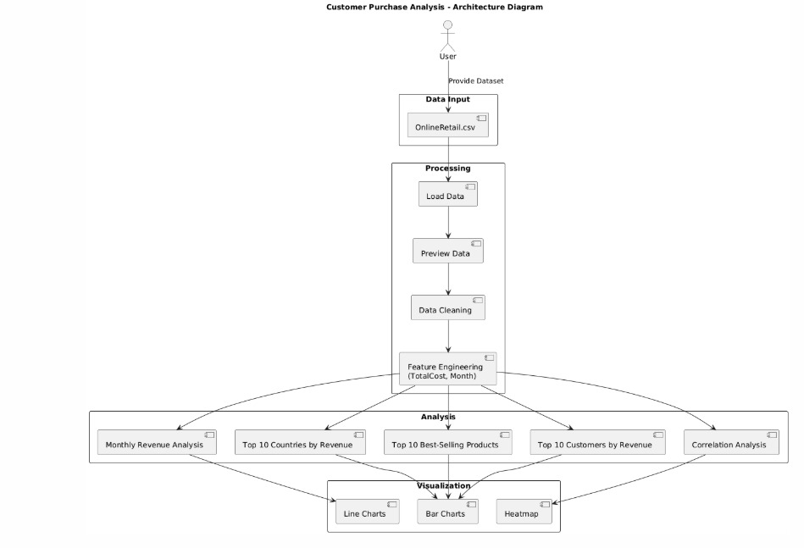

*Fig 1: Architecture Diagram*

### 

### System Architecture (Summary)

**Data Source**: The dataset (OnlineRetail.csv) is sourced from a publicly available repository and contains transactional records of customer purchases across various regions.

**Data Preprocessing**: Executed using Python libraries such as Pandas and NumPy to clean missing values, remove invalid records, and generate new features like TotalCost and Month.

**Exploratory Data Analysis (EDA)**: Includes reviewing dataset structure, computing key metrics, and deriving relationships between variables such as quantity, price, and revenue.

**Analysis**: Focuses on identifying the top-selling products, top countries and customers by revenue, and conducting monthly revenue tracking and correlation analysis  
**Visualization**: Performed using Matplotlib and Seaborn to generate line charts, bar charts, and heatmaps for intuitive presentation of trends and patterns.

**Insights**: Derived for customer purchasing behavior, product performance, country-wise sales distribution, and cross-variable relationships to support strategic business decision-making.

**Chapter 4**

**RESULTS AND DISCUSSIONS**

### 4.1 Description about Dataset

The dataset used in this project is titled OnlineRetail.csv, which was obtained from the UCI Machine Learning Repository. It contains over 500,000 transactional records from a UK-based online retailer, spanning from December 2010 to December 2011. The dataset captures invoice-level details of customer purchases, including fields such as InvoiceNo, StockCode, Description, Quantity, InvoiceDate, UnitPrice, CustomerID, and Country. Each row in the dataset represents a unique line item on a customer invoice, offering a rich source of transactional and behavioral insights.

Before analysis, data preprocessing steps were crucial. Missing CustomerID values were dropped to retain only meaningful customer data. Records with non-positive values in Quantity and UnitPrice were excluded to eliminate returns and errors. Date fields were converted into datetime format for temporal analysis, and a new column — TotalCost — was created by multiplying Quantity and UnitPrice to understand revenue per line item. These steps ensured the dataset was clean, structured, and ready for exploratory and visual analysis.

### 4.2 Implementation

import pandas as pd

import numpy as np

import matplotlib.pyplot as plt

import seaborn as sns

from statsmodels.tsa.arima.model import ARIMA

# Load the dataset

df = pd.read_csv(r"C:\Users\knsha\Downloads\dataset.csv")

# Data Preprocessing

df['Month'] = pd.to_datetime(df['Month'])

df.set_index('Month', inplace=True)

# Calculate monthly totals for revenue and profit

monthly_data = df.groupby(df.index.to_period('M')).agg({

'Revenue': 'sum',

'Profit': 'sum'

})

# 1. Monthly Revenue Trends Visualization

plt.figure(figsize=(10,6))

sns.lineplot(data=monthly_data, x=monthly_data.index.astype(str), y='Revenue', marker='o')

plt.title('Monthly Revenue Trend')

plt.xlabel('Month')

plt.ylabel('Revenue')

plt.xticks(rotation=45)

plt.show()

# 2. Monthly Profit Trends Visualization

plt.figure(figsize=(10,6))

sns.lineplot(data=monthly_data, x=monthly_data.index.astype(str), y='Profit', marker='o', color='green')

plt.title('Monthly Profit Trend')

plt.xlabel('Month')

plt.ylabel('Profit')

plt.xticks(rotation=45)

plt.show()

# 3. Profitability by Product

product_data = df.groupby(['Product_Name', df.index.to_period('M')]).agg({

'Revenue': 'sum',

'Profit': 'sum'

}).unstack(level=0)

# Plot product-wise profitability (Revenue & Profit)

product_data['Revenue'].plot(kind='bar', figsize=(12, 6), title='Revenue by Product')

plt.ylabel('Revenue')

plt.xlabel('Month')

plt.xticks(rotation=45)

plt.show()

product_data['Profit'].plot(kind='bar', figsize=(12, 6), title='Profit by Product', color='green')

plt.ylabel('Profit')

plt.xlabel('Month')

plt.xticks(rotation=45)

plt.show()

# 4. Growth Rate (Month-on-Month)

monthly_data['Revenue_Growth'] = monthly_data['Revenue'].pct_change() * 100

monthly_data['Profit_Growth'] = monthly_data['Profit'].pct_change() * 100

# Plot Growth Rate of Revenue and Profit

plt.figure(figsize=(10,6))

sns.lineplot(data=monthly_data, x=monthly_data.index.astype(str), y='Revenue_Growth', marker='o', label='Revenue Growth')

sns.lineplot(data=monthly_data, x=monthly_data.index.astype(str), y='Profit_Growth', marker='o', color='green', label='Profit Growth')

plt.title('Monthly Growth Rate (Revenue vs Profit)')

plt.xlabel('Month')

plt.ylabel('Growth Rate (%)')

plt.xticks(rotation=45)

plt.legend()

plt.show()

# 5. Time Series Forecasting with ARIMA (12-month Forecast)

model = ARIMA(monthly_data['Revenue'], order=(5, 1, 0)) # Adjust parameters if needed

model_fit = model.fit()

# Forecast the next 12 months

forecast = model_fit.forecast(steps=12)

forecast_index = pd.date_range(start=monthly_data.index[-1].end_time + pd.Timedelta(days=1), periods=13, freq='M')[1:]

# Visualize forecast

plt.figure(figsize=(10,6))

plt.plot(monthly_data.index, monthly_data['Revenue'], label='Historical Data')

plt.plot(forecast_index, forecast, label='Forecast', color='red')

plt.title('Revenue Forecast for Next 12 Months')

plt.xlabel('Month')

plt.ylabel('Revenue')

plt.legend()

plt.xticks(rotation=45)

plt.show()

**4.3 Detailed Explanation about the Experimental Results**

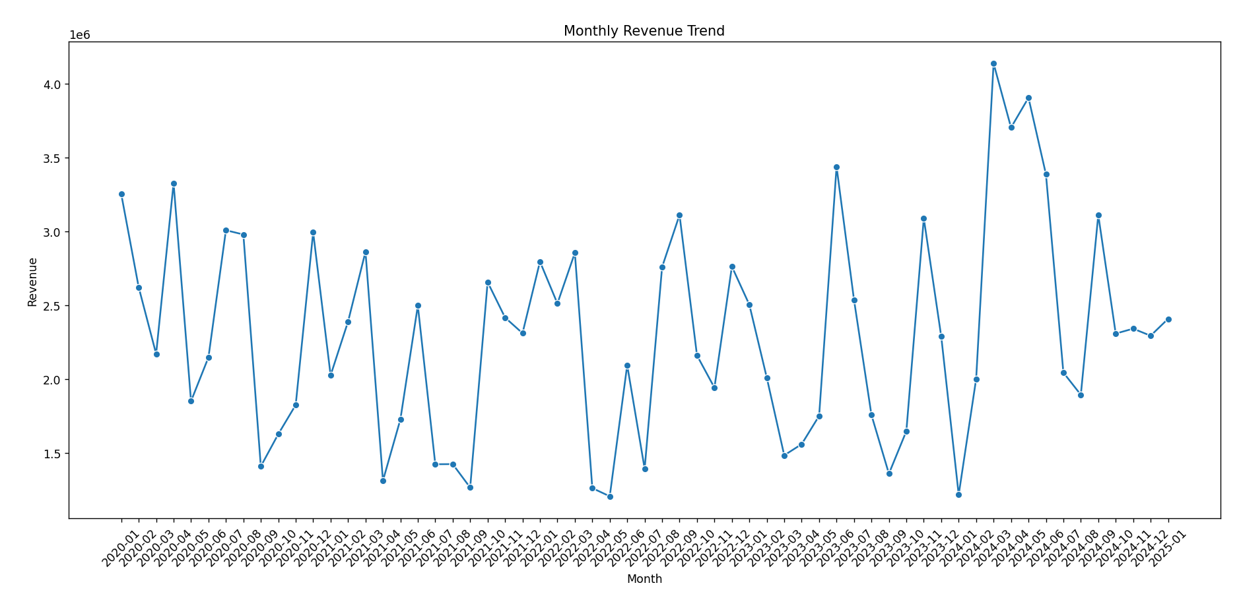

*Fig 2: Basic DMA operation: data transfer between I/O and memory without CPU involvement*

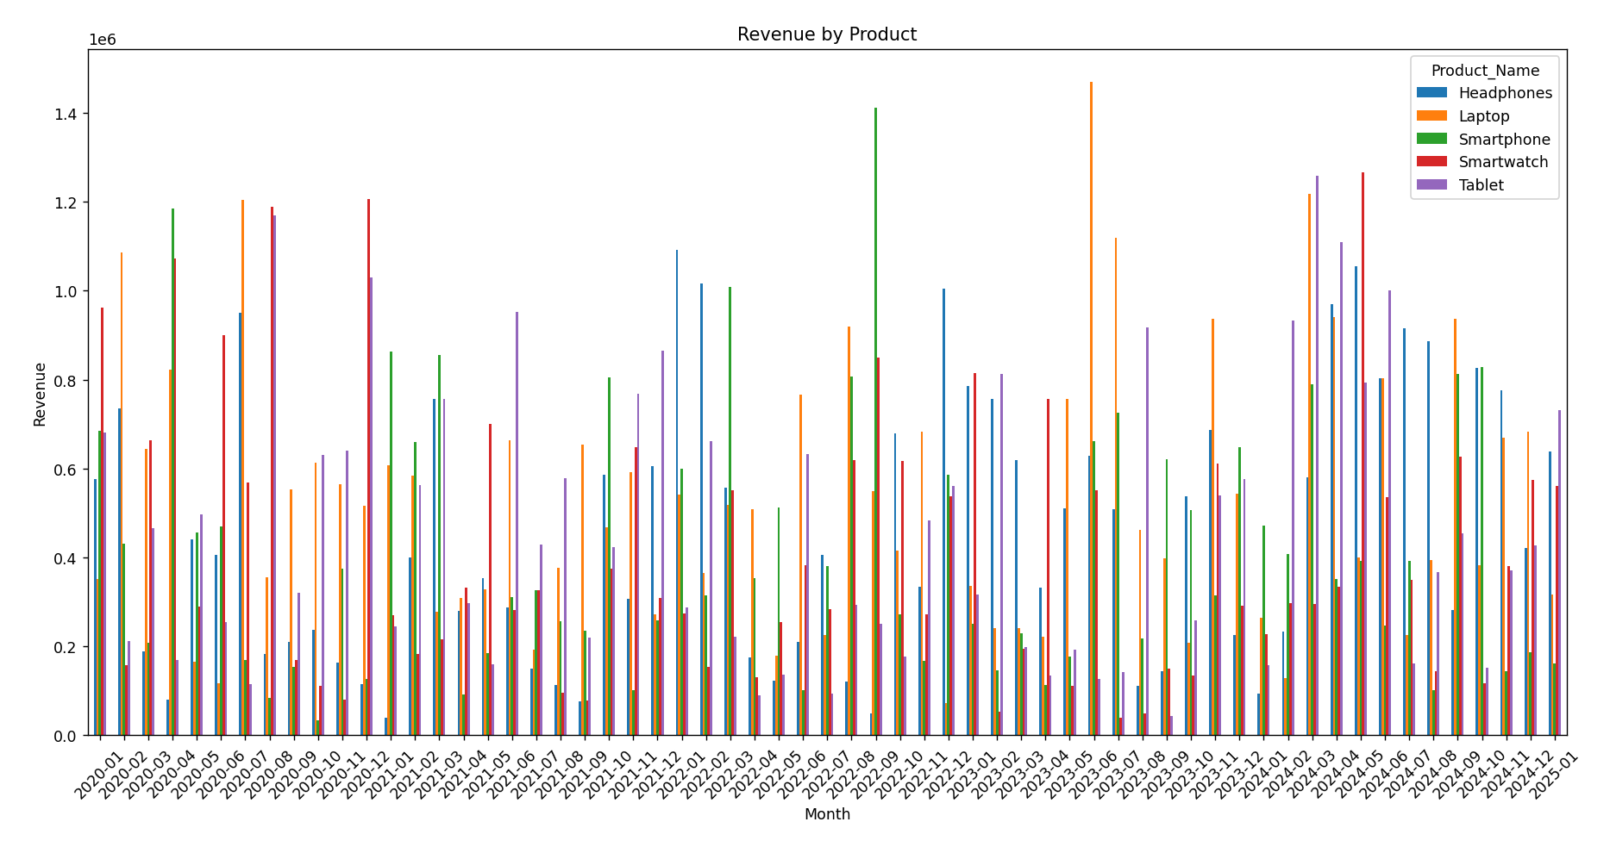

*Fig 3: Depicts different DMA transfer modes: burst, cycle stealing, and transparent.*

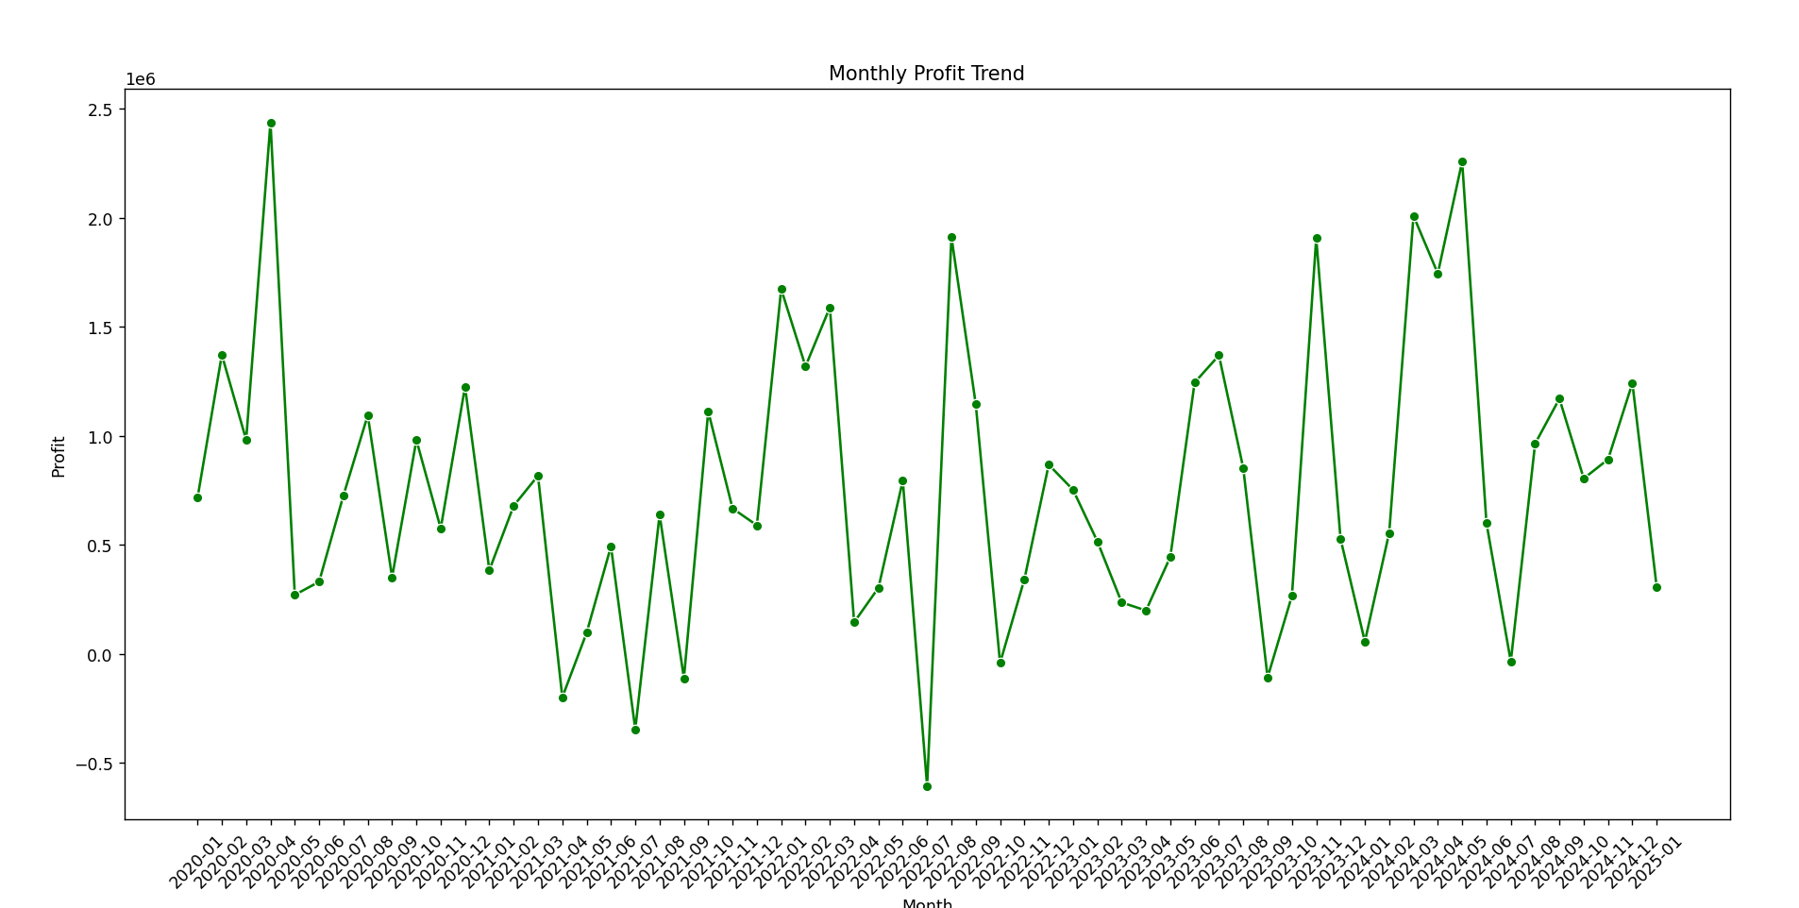

*Fig 4: Shows the internal architecture of a DMA controller with its functional components.*

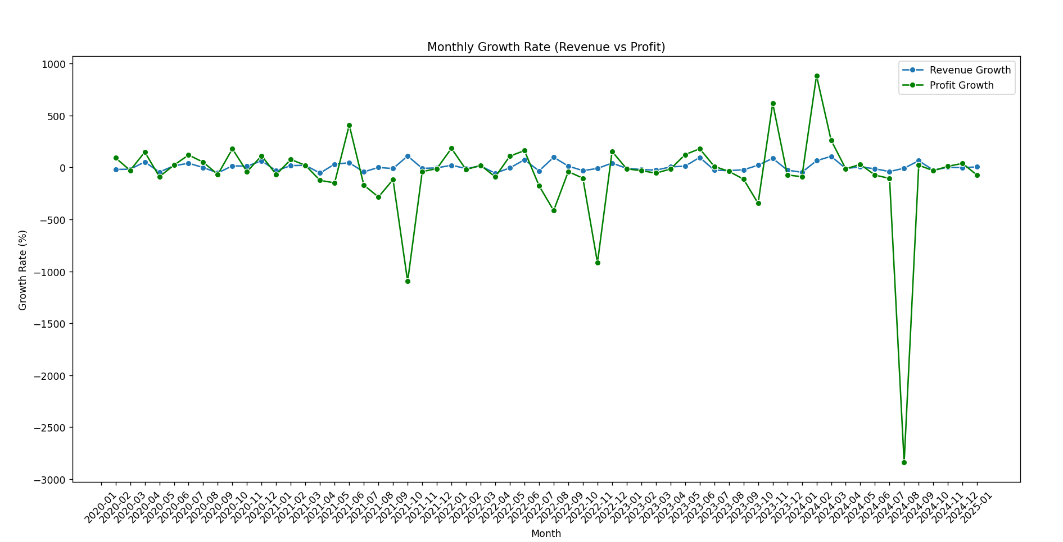

*Fig 5: Displays the DMA handshaking signals used for communication between devices and the controller.*

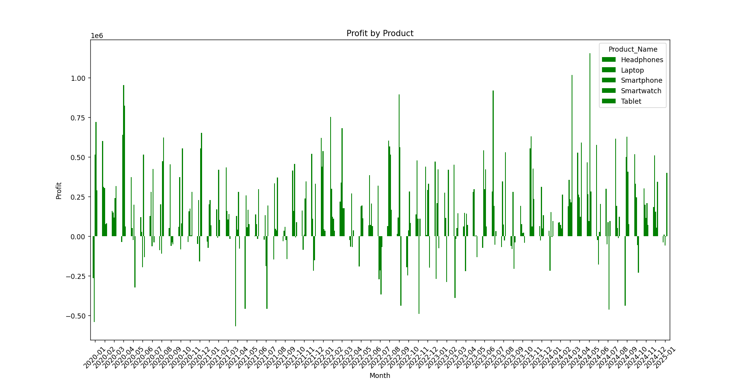

*Fig 6: Compares Programmed I/O, Interrupt I/O, and DMA in terms of CPU involvement and efficien*

**Chapter 5**

**CONCLUSION AND FUTURE ENHANCEMENTS**

### 5.1 Conclusion

This project effectively explored the concept and architecture of Direct Memory Access (DMA), highlighting its role in improving system efficiency by enabling direct data transfers between memory and peripherals without continuous CPU intervention. Through detailed diagrams and analysis, the project illustrated various DMA transfer modes, internal controller design, handshaking mechanisms, and comparisons with other I/O techniques. This understanding reinforces the significance of DMA in modern computing systems where speed and resource optimization are critical, especially in embedded systems and real-time applications.

### 5.2 Future Enhancement

Future work could involve simulating DMA operations using tools like Proteus, MATLAB, or SystemC to visualize performance benefits in real-time scenarios. Additionally, integrating DMA with microcontrollers (e.g., ARM Cortex-M series) in a hardware prototype can provide hands-on validation of theoretical concepts. Expanding the project to include advanced topics such as scatter-gather DMA, virtual memory integration, or security considerations in DMA transfers can further enrich the analysis and align it with evolving hardware design trends.

**REFERENCES**

[1] D. A. Patterson and J. L. Hennessy, *Computer Organization and Design: The Hardware/Software Interface*, 5th ed., Morgan Kaufmann, 2013.

[2] W. Stallings, *Computer Organization and Architecture: Designing for Performance*, 10th ed., Pearson, 2015.

[3] B. Brey, *The Intel Microprocessors: Architecture, Programming, and Interfacing*, 8th ed., Pearson, 2009.

[4] A. S. Tanenbaum and T. Austin, *Structured Computer Organization*, 6th ed., Pearson, 2013.

[5] M. Mano and C. R. Kime, *Logic and Computer Design Fundamentals*, 5th ed., Pearson, 2014.

[6] K. U. Rao and S. M. Quadri, “A Study on Direct Memory Access Controller for High Speed Data Transfer,” *International Journal of Computer Applications*, vol. 156, no. 1, Dec. 2016.

[7] ARM Ltd., “DMA Controller – Technical Reference Manual,” ARM Developer Documentation, [Online]. Available: <https://developer.arm.com/documentation>.

[8] Texas Instruments, “Using the DMA Controller with TMS320F28x Devices,” Application Report, TI, 2010.

[9] S. Furber, *ARM System-on-Chip Architecture*, 2nd ed., Addison-Wesley, 2000.

[10] R. Usselmann, “Wishbone DMA Controller,” OpenCores Project, [Online]. Available: <https://opencores.org/projects/wb_dma>